Importance of the Proper Scissors Grip
Like its close cousin the proper pencil grip, a child must be taught the proper scissors grip.
It is typical for children to explore with their palms facing downward and their little hands outstretched. The proper scissors grip requires a child to twist his hand from the palm-down position so that his thumb faces upward and his pinky finger points at the floor, like he’s getting ready to shake someone’s hand. As if that position wasn’t unfamiliar enough for a child, he then needs to spread his thumb and pointer finger as far apart as possible to make the blades of the scissors open.
Due to the complexity of the correct scissors grip, it is common for young children to hold and try to use scissors incorrectly.
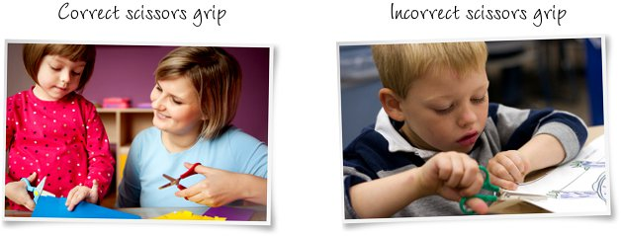
While cutting, your child will also need to learn how to use his non-dominant hand to hold the paper. Initially the non-dominant hand will just need to hold the paper still as the dominant hand moves the scissors forward in a straight line. Eventually, though, the non-dominant hand will need to move and turn the paper as the dominant hand opens and closes the scissor blades.

Tips for teaching your child the proper scissors grip
Most children become interested in scissors around age two and a half or three. When your child first shows an interest in using scissors, I have a few tips I recommend to help him quickly master the proper scissors grip.
- Let your child just practice holding the scissors without the stress of being expected to cut anything. Getting your child to hold the scissors the right way each time he picks them up is a challenge in and of itself, so encourage him to pick them up then put them down as many times as he wants.
- Show your child how he needs to spread his index finger and thumb as wide as possible to open the blades of the scissors and then how he needs to close his fingers to close the blades of the scissors. Explain that the wider he opens his fingers, the longer his cuts will be.
- Don’t go too far away. I realize that most parents likely won’t leave their child unattended with scissors at the risk of the child giving himself or a sibling an impromptu haircut. But you should also stay nearby so you can continue giving your child verbal clues such as “Now open your fingers really wide” or “Turn the paper with your left hand so you can cut out that circle.” Without these supportive comments, until your child is comfortable with the correct scissors grip, he may revert to an incorrect grip (or to use both hands to open and close the blades of the scissors by putting one hand on each handle). These incorrect approaches will likely produce a snip in the paper, but they are inefficient and imprecise.

Try this at home
If your child is still struggling with the correct scissors grip, have him put the scissors down and shake your hand. When your child reaches to shake your hand, he will naturally rotate his hand so that his thumb is on top and his pinky finger is pointing towards the floor.
After you shake hands with your child once or twice, ask him to shake a third time. This time, as he extends his hand to you to shake, use your hand to pick up a pair of scissors by the closed metal blades and place the end of the scissors with the finger holes into his outstretched palm. Then verbally instruct him to put his thumb in the loop on top of the scissors and to put his index finger (or index finger and middle finger together) in the loop on the bottom.
Once your child is holding the scissors correctly, pick up a piece of paper and let your child cut through it a few times without worrying about using his non-dominant hand to steady the paper.

Video Clip
The following is helpful video clip to show your child the correct way to hold scissors.
http://video.about.com/babyparenting/Using-Scissors.htm

*If you do not have child friendly scissors at home, the Dollar Tree and Walmart are great places to find them!

